IOWA
Model the Way
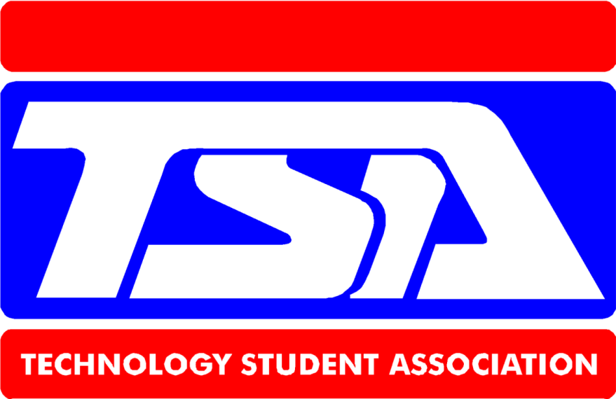
STATE CONFERENCE 2019

April 8 & 9

2019 Iowa State Conference Agenda

Monday, April 8

11:30 – 1:00 Advisors Check-in Conference Coordinator Suite 223; pick up t-shirts, name tags, and confirm registration information

12:30 – 3:00 Check-in for all drop-off events in room #3 on 2nd floor

12:30-1:00 RC car team captains sign in at the Race Track Site

1:15 Delegate seating in Palace Theatre

*Each chapter must have voting delegates in attendance to vote*

1:30-2:15 Conference Opening Ceremony in Palace Theatre – officer candidate speeches

3:00 – 9:00 Competitive Events- Check in at the competition site immediately after the opening ceremony
7:00-7:30 Advisory Board meeting- parents and chaperones in hotel lobby
10:00 Advisors and Board meeting

Room 5

11:00 Curfew, all students in rooms

12:00 Lights out

Tuesday, April 9

7:30 -10:30 Competitive Events

10:00-11:00 Pick up projects

10:30 Delegate seating and vote

11:30 Closing Ceremony and Awards

American Cancer Society Collection

*Awards Made by Johnston High School, Construction Technology Class

2018-19 TSA State Officer Team

President: Ellie Smith, Waukee

Vice President: Lauren Saxton, Central Decatur

Secretary: Maddy Leahy, Central Decatur

Treasurer: Lauren Soll, Panorama
Reporter: Luke South, Panorama

Sergeant-at-Arms: Regan Peter, Boone

2019 National TSA Conference
June 28 – July 2, 2019
National Harbor near Washington, DC

2018-19 High School TSA

Competitive Events Locations & Times

Architectural Design - Room #3

Check in Monday 12:30 – 3:00 p.m.
5 teams of up to 4 students per chapter

Mike Hehnke, Winterset

Chapter Excellence – Room 224

Check in Monday 12:30 - 3:00 p.m.

Interviews 4:00 – 5:00 p.m.

One entry per Chapter

Kent Seuferer, DOE

Chapter Team - Room #2

Monday 6:00 – 9:00 p.m.

Assemble in Room #5

2 teams of 6 students per chapter

Nick Crosse, Johnston

Children’s Stories – Room #3

Check in Monday 12:30 – 3:00 p.m.

2 teams per chapter

Shelly Vanyo, Boone

HS Events

CIM – Room #3

Check in Monday 12:30 – 3:00 p.m.

5 teams of 2 per chapter

Tom Buckman, Burlington

Computer-Aided Drafting, 2D & 3D
Room #5

Check in Monday 12:30 – 3:00 p.m.

Drafting Monday 4:00 – 7:00 p.m.

Andrew Hauptmann, Waukee

Debating Technical Issues – Suite 282

Check in Monday 12:30 – 3:00 p.m.

3 teams of 2 students per chapter

Monday 6:00- 7:00 p.m.

Mike Hehnke, Winterset

Digital Video Production - Room #2

Check in Monday 12:30 – 3:00 p.m.

2 teams of 3 students per chapter

Robin West, ADM

HS Events

Dragster Design - Balcony

Check in Monday 4:00 p.m.

5 individuals per chapter

Rhys South, Johnston
Extemporaneous Presentation –Room #1
Monday 5:00 – 7:00 p.m.
3 individuals per chapter
Todd VanderVelde, Rock Valley
Fashion Design - Palace Theater Stage
Check in Monday 6:30, Show 7:00
3 teams of 3 – 5 students per chapter
Robin West, ADM

Flight Endurance- Palace Theater

Check in Monday 12:30-3:00 p.m.
Flights Monday 4:00 - 5:00 p.m.
4 individuals per chapter
Larry Johnson, CD
Forensic Science –
Check in Monday 12:30-3:00 p.m.
Scheduled Crime Scene Investigation

Barb South, Panorama
Music Production – Room #3
Check in Monday 12:30-3:00 p.m.
3 teams of 1 or more
Shelly Vanyo, Boone HS
Photographic Technology - Room #3
Check in Monday 12:30 – 3:00 p.m.
5 individuals per chapter
Gene Olsen, Central Decatur

HS Events

Prepared Presentation - Room #1

Monday 4:00 – 5:00 p.m.

3 individuals per chapter

Todd VanderVelde, Rock Valley

Promotional Design - Room #3

Check in Monday 12:30 – 3:00 p.m.

5 individuals per chapter
Robin West, ADM

Radio Control Transportation
Race in parking lot or Palace Theater

Check in Monday 12:30 – 1:00 p.m.

**Races as assigned - Finals Tuesday

5 teams of 3 students per chapter

Curt Cornelius, Perry

Structural Engineering - Iowa Cafe

Build Time Monday 3:30-5:30 p.m.

3 teams of 2 students per chapter

Testing Monday 7:30 p.m.

Ben Chadwick, SMS

HS Events

Technology Bowl - Spectator’s Suite
Check in 7:00-7:20 a.m.
Event time Tuesday 7:30- 10:00 a.m.
2 teams of 3 students per chapter

Technology Problem Solving - Iowa Cafe
Check in 6:30 p.m.

Monday 7:00 - 9:00 p.m.

3 teams of 2 students per chapter

Taylor Shaw, ISU

Transportation Modeling - Room #3

Check in Monday 12:30 – 3:00 p.m.

3 individuals per chapter

Gene Olsen, CD HS
Vex Turning Point- Palace Theater Foyer
Check in 7:30 a.m. Tuesday
Contests begin at 8:00 a.m.
3 teams of 3

Rhys South, Johnston

**If you have a conflict between two events you need to talk to both event coordinators and see if a compromise may be worked out.
**Check in at your event.

**Event coordinators are the experts in their respective events and will have
the final word in any results for their contest.
**TSA attire and name badges are required for all competitive events. TSA attire would include a local chapter shirt, or the state conference shirt. No hats inside the building during competition.
2018-19 Middle School TSA

Competitive Events Locations & Times

Career Prep - Room #3

Check in Monday 12:30 - 3:00 p.m.

Bring cover letter and resume

Sign up for interview time

Interviews from 5:00-6:00 p.m.

Room 224
3 individuals per chapter

Barb South, Panorama

Challenging Technology Issues- Room #4

Monday 3:45 - 5:30 p.m.

2 teams of two per chapter

Dennis Erb, Boone

Chapter Excellence – Suite 224

Check in Monday 12:30 - 3:00 p.m.

Interviews 4:00- 5:00 p.m.

One entry per Chapter

Kent Seuferer, DOE

MS Events

Chapter Team -Room -#2

Monday 6:00 - 9:00 p.m.

Assemble in Room #5

2 teams of 6 students per chapter

Nick Crosse, Johnston

Children’s Stories – Room #3

Check in Monday 12:30 – 3:00 p.m.

3 teams per chapter

Larry Johnson, CD

Community Service Video -Room #5

Check in Monday 12:30- 3:00 p.m.

3 teams of 5 students per chapter

Joe Huebbe, JMS

MS Events
Digital Photography - Room #3
Check in Monday 12:30 - 3:00 p.m.
4 individuals per chapter
Jayce Carter, Boone MS

Dragster - Balcony

Check in Monday 4:00 p.m.

Time trials Monday 4:00- 8:00 p.m.

5 individuals per chapter

Rhys South, JHS

Flight Challenge- Cone Shop

Build Time Monday 3:30 – 5:30 p.m.
Flights Monday 5:30 – 6:30 p.m.
4 individuals per chapter
Heidi Lumbard, SWV HS
Junior Solar Sprint – Balcony
Check in Room #3 Monday 12:30-3:00
Race at CO2 Track 7:00 p.m.

MS Events
Mass Production – Room #3
Check in Monday 12:30 - 3:00 p.m.
2 Teams of 2-4 students per chapter
Mike Hehnke, Winterset
Off the Grid – Room #3
Check in Monday 12:30 - 3:00 p.m.
3 teams per chapter
Mark Eppert, Perry
Prepared Speech - Room #4
Monday 5:30 - 7:00 p.m.
3 individuals per chapter
Dennis Erb, Boone

Promotional Marketing- Room #3

Check in Monday 12:30 – 3:00 p.m.

5 individuals per chapter

Joe Huebbe, Johnston

MS Events

Radio Control Transportation
Location: race in Parking Lot

Check in Monday 12:00 - 1:00 p.m.

Finals Tuesday a.m. will be posted

Races as assigned

5 teams of 3 students per chapter

Curt Cornelius, Perry

Structural Engineering - Iowa Cafe

Build Time Monday 5:30-7:30 p.m.

Testing Tuesday 8 a.m.- Balcony

3 teams of 2 students per chapter

Joe Huebbe, Johnston

MS Events
Tech Bowl - Spectator’s Suite
Check in 12:30 - 3:00

Event Monday 5:00 – 7:00 p.m.

2 teams of 3 students per chapter

Vickie Lee, Alumni

Tech Problem Solving - Iowa Cafe

Tuesday 7:00 a.m Check in

Contest 7:30 - 9:00 a.m.

3 teams of 2 students per chapter

Taylor Shaw, ISU

Technical Design – Room #5

Check in 12:30-1:00

Problem will be posted Sunday April 10

2 teams per chapter

Andrew Hauptmann, Waukee
Vex Turning Point- Palace Theater Foyer
Check in 7:30 a.m. Tuesday
Contests begin at 8:00 a.m.
3 teams of 3

Rhys South, JHS

Website Design- Room #3

Check in 12:30-3:00

1 team of 3-6 members

Robin West, ADM

2018-19 TSA Board of Directors

President: Joe Huebbe, JMS (2017)

Secretary: Robin West, ADM (2016)

Treasurer: Rhys South, JHS (2018)

Barb South, Panorama (2018)

Dennis Erb, BMS retired (2016)

Curt Cornelius, PHS (2017)

Student Representative: Ellie Smith, President

Corporate Member: Kent Seuferer, Iowa DOE

State Advisor: Gene Olsen, Central Decatur

Conference Event Coordinator: Becky Mozingo

Conference Facility Coordinator: Rhys South

Conference Secretary: Kris Full

Conference Overnight Security:

TSA Website Coordinator: Robin West

The Technology Student Association's Motto: Learning to lead in a technical world.
The Technology Student Association's Creed:
I believe that Technology Education holds an important place in my life in the technical world. I believe there is a need for the development of good attitudes concerning work, tools, materials, experimentation, and processes of industry.
Guided by my teachers, artisans from industry, and my own initiative, I will strive to do my best in making my school, community, state, and nation better places in which to live.
I will accept the responsibilities that are mine. I will accept the theories that are supported by proper evidence. I will explore on my own for safer, more effective methods of working and living.
I will strive to develop a cooperative attitude and will exercise tact and respect for other individuals. Through the work of my hands and mind, I will express my ideas to the best of my ability.
I will make it my goal to do better each day the task before me, and to be steadfast in my belief in my God, and my fellow Americans.

